CAMELOT SPA SELF-CATERING VILLA ACCOMODATION

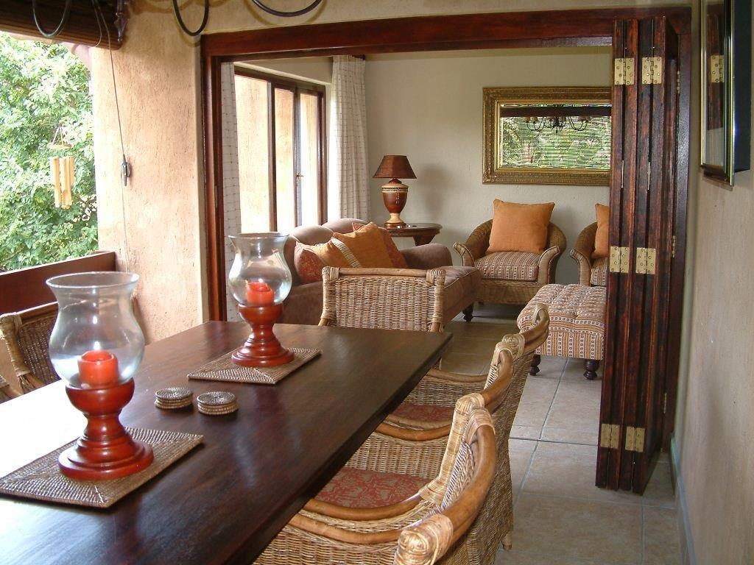

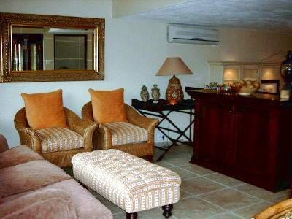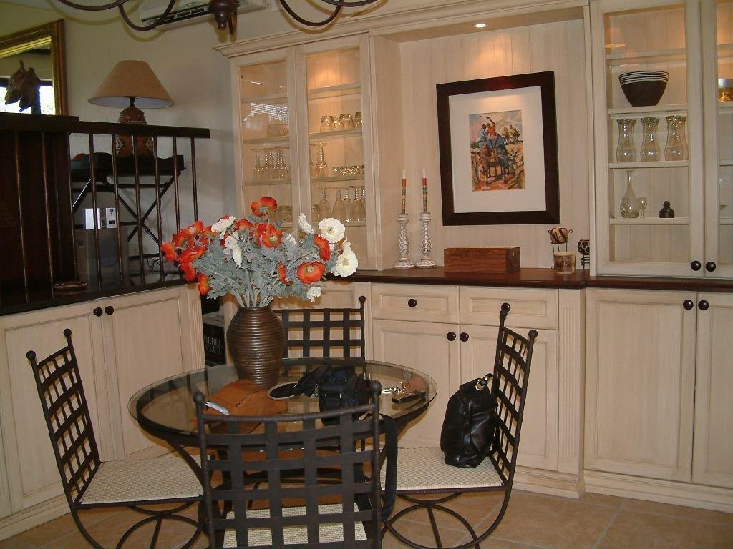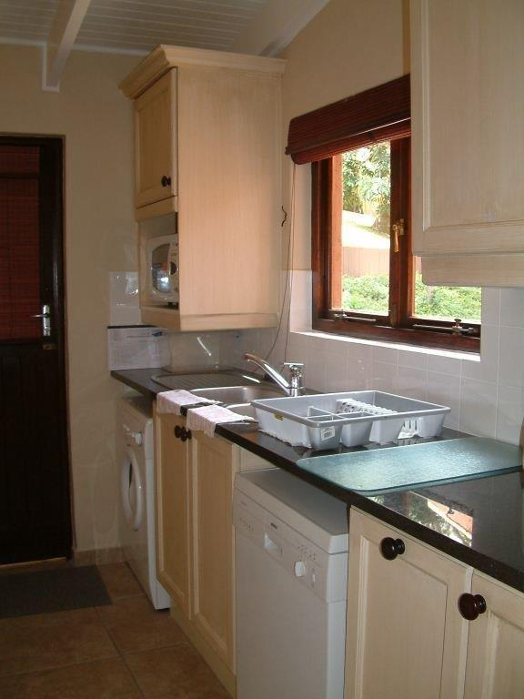

4 bedroom villa – 10 sleeper

This earth toned villa is nestled in the middle of the secure San Lameer Eco and Golf Estate near Camelot Spa so it’s ideal for people who wish to have wellness holidays. It offers 4 bedrooms that sleep 6 adults and 4 children. There is a fully equipped kitchen with dishwasher and washing machine/tumble dryer, breakfast nook, wine fridge, lounge with TV and DSTV connection. The lounge leads out onto a patio that can be protected with roll down blinds. It has a gas braai which makes it the favourite dining spot. The first double bedroom with en-suite bathroom is on the ground floor, down the stairs are two bedrooms with two single beds in one and 4 bunk beds in the other. Leading off these bedrooms is a deck which is ideal for relaxing in the afternoon. There is a skottle braai and loungers. The ideal spot for bird watching. The main bedroom is upstairs, very private and has big windows looking out over the trees, a king size bed and en-suite bathroom with shower. The villa has lots of cupboard space.
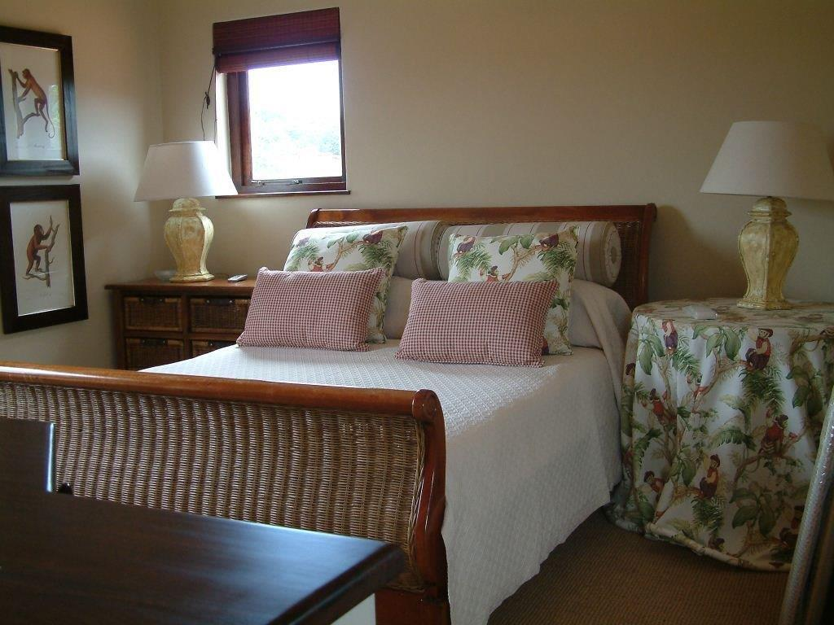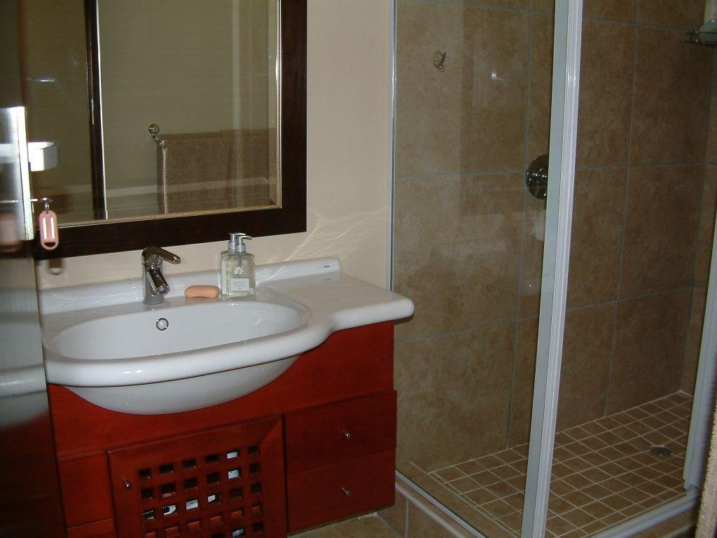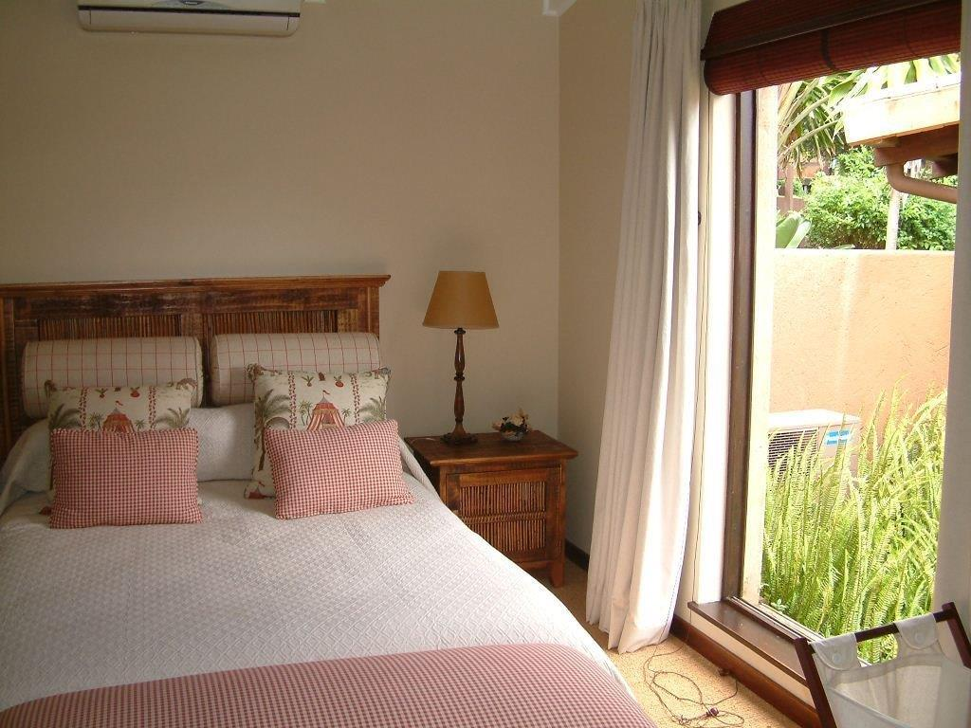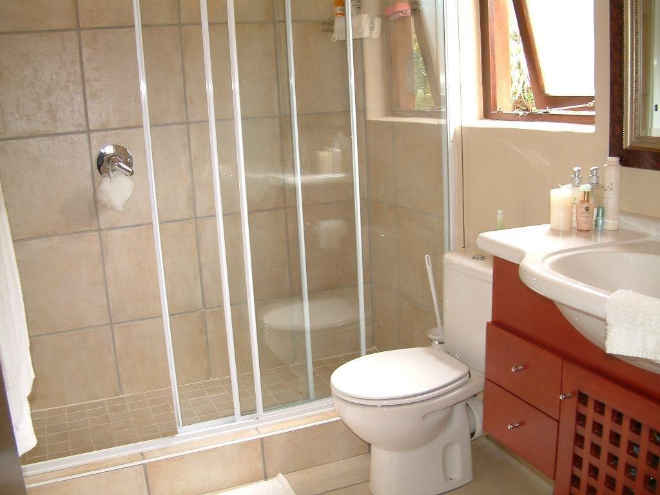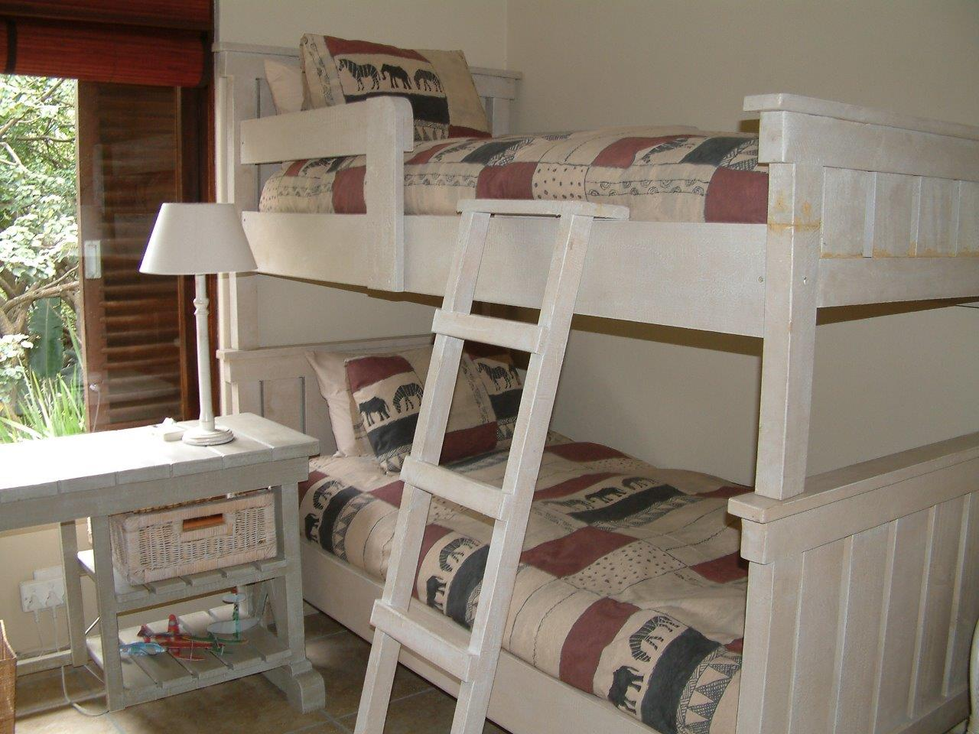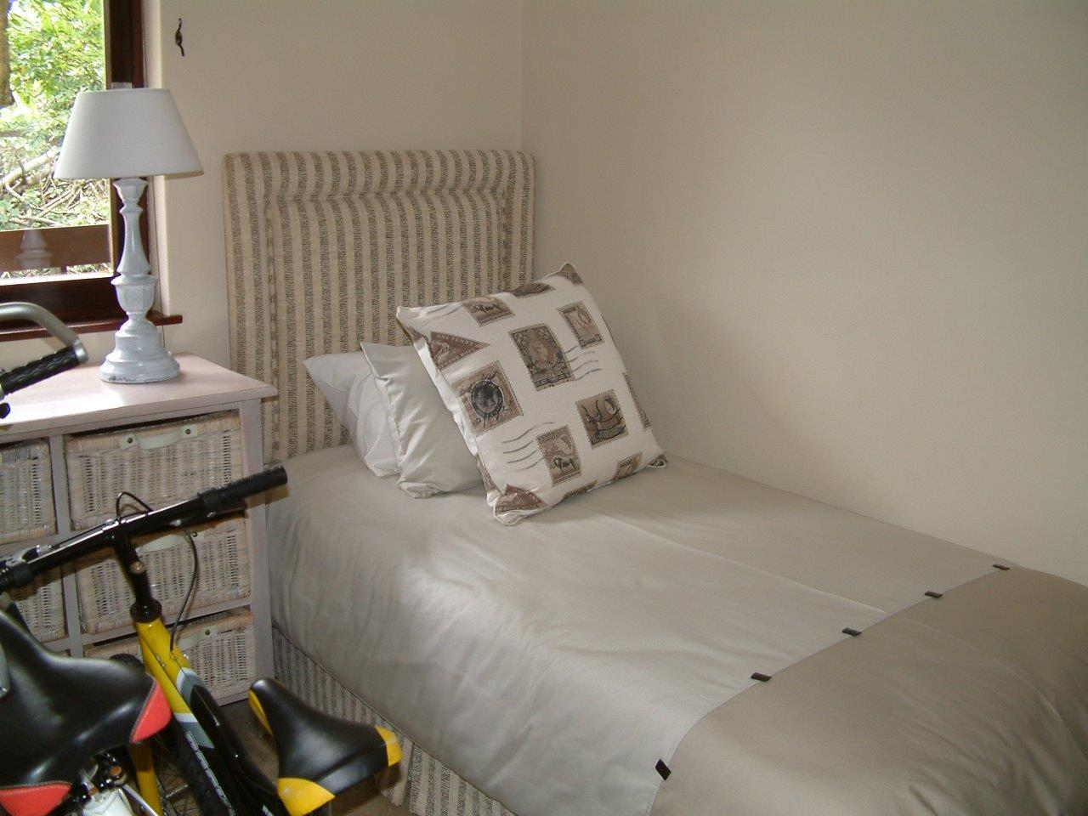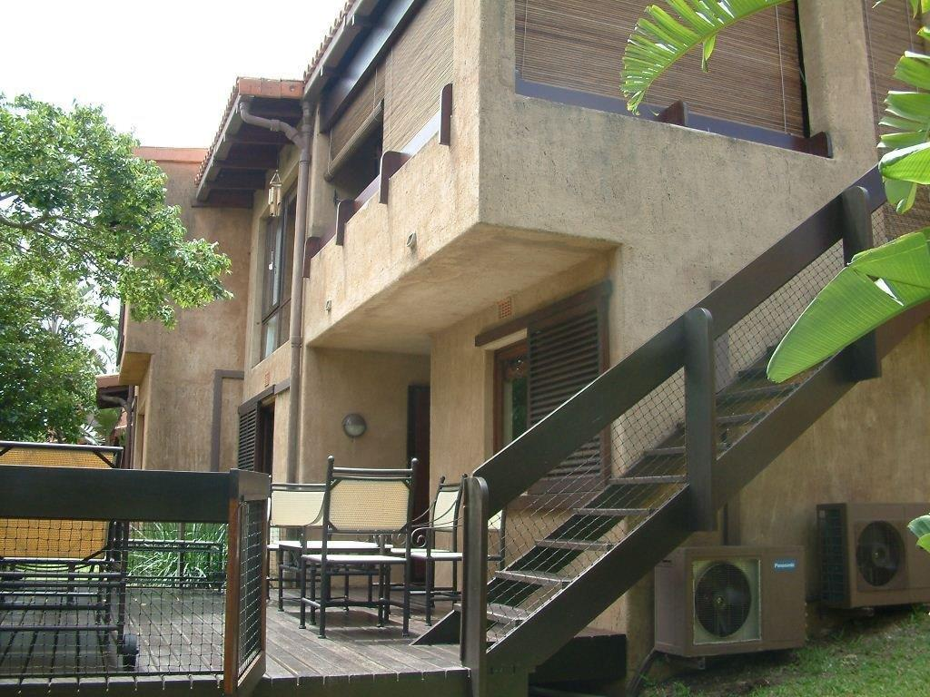

The Estate
The villa is an easy walk to the magnificent Marina beach. The 2km stretch of white sand and warm sea are rated with blue flag status. It is also an easy walk along the nature trail to the San Lameer Estate hotel and Camelot Spa. The Golf club offers a challenging game and a great way to see the game on the Estate. Other activities on the Estate are tennis courts, squash courts, volley ball, bowls, walking and cycling trails.
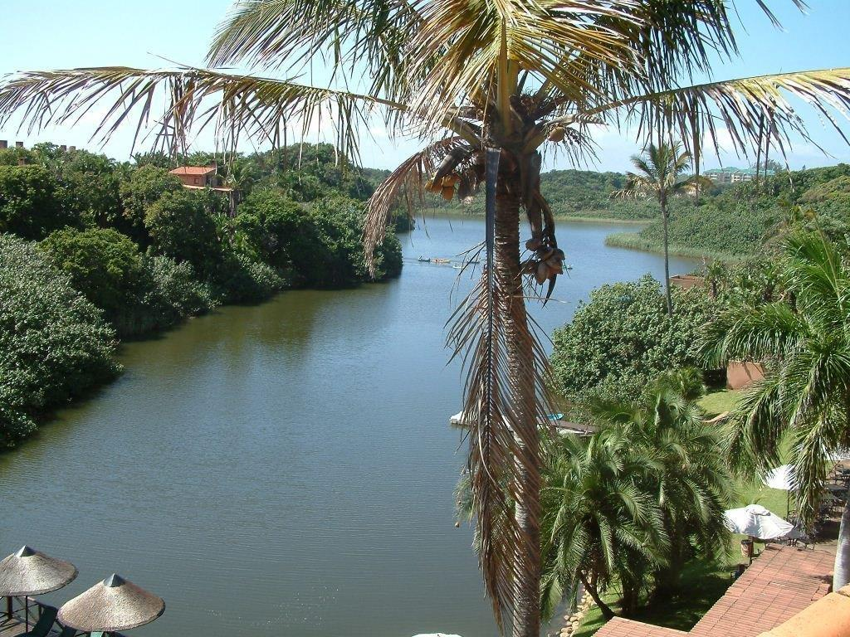

Nearby
Enjoy deep sea fishing, horse riding, scuba diving, quad biking and game viewing all within a few minutes’ drive.
Features:
4 bedroom
3 bathrooms
DSTV
Modern finishes
Stylishly furnished
Close to beach
Overlooking the lagoon
Private
Air-conditioned
Arrival and Departure cleaning service included
Golf Estate
Camelot Spa on Estate
2 restaurants on Estate
Many excellent restaurants in the area
Many things to do on the Estate and near

LOW SEASON MID SEASON PEAK SEASON
R 2 500 R 2 800 R 3 800

Mid season applies to school holidays and long weekends
Peak season applies to Easter School holidays and all of Dec and 1 -15 Jan
All other times are considered low season

There is a minimum of 2 days stay.

ALL PRICES ARE SUBJECT TO CHANGE

Terms & Conditions
Villa may only be occupied after 12h00 on date of arrival.
Villa must be vacated by 10h00 on Departure date. There is an inventory list in the Villa. It is your responsibility to check the inventory and report within 12 hours of arrival if anything is not correct. Should any items be broken or missing when the departure service is done you will be responsible for payment. This amount will be deducted from the deposit before repayment.

*A deposit of 50% of the total cost is required to secure your Reservation and full payment must be made at least 7 days before arrival.

Vehicle and Access Costs
R100.00 per vehicle for anything up to 7 days and R100 per week after.
The fees per vehicle will not be transferrable between vehicles. A family with more than one vehicle will thus have to purchase more than one permit. A maximum of 2 vehicles for a 4 bedroom villa as parking is restricted.

Cleaning services
If you stay for more than two days the arrival and departure cleaning service is included in the price. Should you stay for less than 2 days you will be responsible for payment of the arrival and departure cleaning service which is R805.

Inventory
Inventory list will be in the Villa when you arrive. Should you find any discrepancies these must be reported on the day or arrival. The inventory list will be checked by cleaners before you arrive and immediately after you leave the Villa. Any breakages or damage or missing items will be deducted from your breakage deposit before it is refunded to you.

Deposit and Final payment
This provisional reservation will be confirmed by your signed acceptance of the following terms and conditions and only after receiving confirmation of payment of your deposit, or of the total amount.

The payments may be deposited into our bank account:
It is expressly recorded that the interest on such amount or amounts deposited shall be for the benefit of The Tenth Southbroom Trust. Please either fax or email a copy of your deposit slip at your earliest convenience, clearly indicating your invoice number as a reference. In the case of cancellation within 60 days of booking your deposit WILL NOT BE REFUNDED unless an alternative reservation can be finalized for the same period reserved for you.

PLEASE COMPLETE THE TWO ATTACHED DOCUMENTS WHEN PAYING FOR YOUR BOOKING.

